Rf100 million can be reduced from allowances instead of altering salaries of government staffs, says President Nasheed
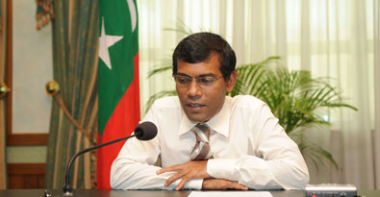
President Nasheed has said without changing salaries, the government will be able to reduce Rf100 million from various allowances paid to the government employees.
Speaking on the government’s approach for reducing its wage bill in his weekly radio address on Friday, the President said currently at least twenty-four types of allowances were being paid.
The President said the government was holding discussion with the Civil Service Commission and other Independent Commissions on the proposed cost-cutting measures.
He added the government had planned to reduce about Rf100 million per month from the wage bill.
The government had last month decided to take a number of cost reducing measures beginning from 1 September 2009 and stabilise public finances.
The President however acknowledged the government was also facing several difficulties in taking some of the measures.
On the government’s universal health insurance to be introduced next month, the President said fulfilling the pledge was a key objective of the government.
He noted the government was introducing the universal health insurance scheme much earlier than previously thought.
President Nasheed further said the government had plans to assist families who were struggling with their living. He added that his hope and goal was to facilitate a ‘clean life’ for all.
“It is a goal of this government to find ways to change the condition where people are unable to pay their phone bills, water bills, electricity bills, rents, or do not have money for education and health care.
“We are trying to realise this goal, and we are confident that we will be able to do this,” said President Nasheed.
In his radio address, the President also spoke on the first term of the People’s Majlis. He said that the term ended without any legislative work completed.
He continued while the purpose of the Majlis was to make legislation, no single bill was passed during the past three months.
The President said the opposition DRP was totally focused on exploiting the Majlis to pass on a single piece of legislation.
He said while due privileges and respect should be accorded to former presidents, they should also have the right to defend themselves against allegations in a court of law.
On the Decentralisation Bill, the President said some members of the People’s Majlis argued that interpreting the term ‘atoll councils’ as ‘provincial councils’ was a trick.
He however said the government believed ‘atoll councils’ could be taken to be ‘provincial councils’.
He further said running 21 administrative regions or small administrative regions would be expensive and that would not be economically viable.
He said that the provinces would be developed, with or without a decentralisation law.

