President Nasheed meets with delegation of the Communist Party of China
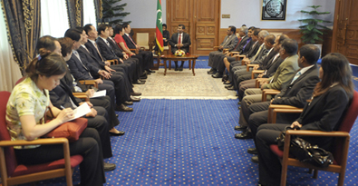
President Mohamed Nasheed has today met with the delegation of the Communist Party of China. The meeting was held this morning at the President’s Office. The head of the delegation is Member of the Political Bureau of CPC Central Committee and Secretary of the CPC Tianjin Municipal Committee, Mr Zhang Gaoli.
Speaking at the meeting, President Nasheed said that Maldives and China enjoyed close friendly bilateral relations and that these ties had been strengthened over the years through enhanced cooperation in various aspects of development. He further said that Chinese assistance towards the housing project was symbolic of the commitment towards enhancing these strong relations.
Highlighting that China was an important development partner of the Maldives, the President thanked the Chinese Government for its generous assistance over the years in important areas such as infrastructure and human resource development.
President Nasheed also said that climate change was an issue of great concern for all Maldivians. He said he was confident that the Maldives would receive Chinese assistance and support in overcoming the challenges posed by climate change.
Noting that Tianjin was one of the fastest growing cities in China, the President praised Mr Zhang Gaoli for his personal role in the development of Tianjin.
Mr Zhang Gaoli said that bilateral relations had grown from strength to strength since the establishment of diplomatic relations between the two countries in 1972 and that cooperation in the areas of trade, tourism and sports had further consolidated the ties between the two countries. He also that China viewed the Maldives as a close friend and assured the President that China would always maintain its close and friendly relations with the Maldives.
Stating that China too was concerned over the issue of climate change, Mr Gaoli said that China would support and assist the Maldives in everyway possible with regard to climate change adaptation and mitigation.
He also congratulated President Nasheed for his victory at the first ever democratic elections held in the Maldives and expressed confidence that the Maldives would achieve greater development and prosperity during the President’s tenure.

